3MTT Darey.io NextGen Cohort
Software Quality Assurance Project Assignment
Topic: Test Execution and Bug Reporting (CAPSTONE 2)
Submitted By:
Name: Nliam Stanley
Date: 25/06/2029y
1. Project Overview
The objective of this project is to perform test execution on a selected web application, validate its functionality against expected requirements, and document any defects discovered during testing using a structured bug reporting format.
For this project, the SauceDemo Website was used as the test application.
Website Tested: https://www.saucedemo.com⁠�
2. Project Objectives
The main objectives of this testing exercise were:
Execute predefined test cases on the application.
Verify that system functionality works as expected.
Identify and document any defects found during testing.
Provide evidence of test execution results.
Assess the overall quality and stability of the application.
3. Test Environment
Item
Details
Application
SauceDemo
URL
https://www.saucedemo.com⁠�
Browser
Google Chrome
Operating System
Windows 10
Testing Type
Functional Testing
Tester
Student QA Engineer
Test Date
25/06/20206
4. Test case Executed
Test Case ID | Test Scenario | Expected Result | Actual Result | Status
TC_001 | Login with valid credentials | User should successfully log in | User logged in successfully | Pass
TC_002 | View product inventory | Product list should display correctly | Product list displayed correctly | Pass
TC-003 | Add item to cart | Selected item should be added to cart | Item added successfully | Pass
TC-004 | Remove item from cart | Item should be removed from cart | Item removed successfully | Pass
TC-005 | Proceed to checkout | User should navigate to checkout page | Checkout page opened successfully | Pass
TC-006 | Enter checkout information | System should accept valid information | Information accepted successfully | Pass
TC-007 | Complete purchase | Order confirmation should be displayed | Order completed successfully | Pass
TC-008 | Logout from application | User should be logged out | Logout successful | Pass
TC-009 | Login with invalid password | Error message displayed | Error displayed | Pass
TC-10 | Login with locked-out user (Negative) | Access denied | Access denied | Pass
TC-11 | Login with empty username (Negative) | Validation message displayed | Validation message displayed | Pass
TC-12 | Login with empty username (Negative) | Validation message displayed | Validation message displayed | Pass
TC-13 | Access checkout with empty cart (Negative) | Checkout prevented | Checkout blocked | Pass
TC-14 | Checkout without first name (Negative) | Validation message displayed | Validation displayed | Pass
TC-15 | Checkout without postal code (Negative) | Validation message displayed | Validation displayed | Pass

4. TEST EXECUTION SUMMARY
Metric Result
Total Test Cases executed 15
Passed Test Cases 15
Failed Test Cases 0
Blocked Test Cases 0
Defects Found 1
Test Completion Rate 100%

5. Summary
A total of 15 test cases were executed, covering both positive and negative scenarios. All test cases passed successfully. Negative testing confirmed that the application properly validates incorrect inputs and prevents invalid actions.

6. Bug Report
Bug ID: BUG-001
Field Details
Bug Title Browser Back Button Returns User to Completed
Checkout Flow
Module Checkout

Severity Low

Priority Medium
Status Open
Environment Chrome Browser, Windows 10

Description
After successfully completing an order, using the browser Back button allows navigation back into the completed checkout process.

Steps to Reproduce
- Login with valid credentials.
- Add a product to cart.
- Complete checkout successfully.
- Click the browser Back button.
Expected Result
The user should remain on the order confirmation page or be redirected to the inventory page.
Actual Result
The user can navigate back into the completed checkout workflow.

7. Business Risk Analysis
Risk Area | Potential Impact
Login Failure | Users cannot access accounts or make purchases
Cart Functionality Failure | Customers may abandon purchases
Checkout Validation Failure | Incomplete customer Information may be captured
Checkout Defects | Revenue loss and poor customer experience
Session Handling Issues | User confusion and duplicate transactions

8. Recommendations
- Improve session handling after order completion.
- Perform regular regression testing before deployments.
- Expand negative testing coverage for checkout workflows.
- Automate critical business flows such as Login, Add to Cart, and Checkout.
- Review validation messages to ensure consistency and clarity.
9. Evidence of Testing
The following evidence should be attached to support the testing activity:
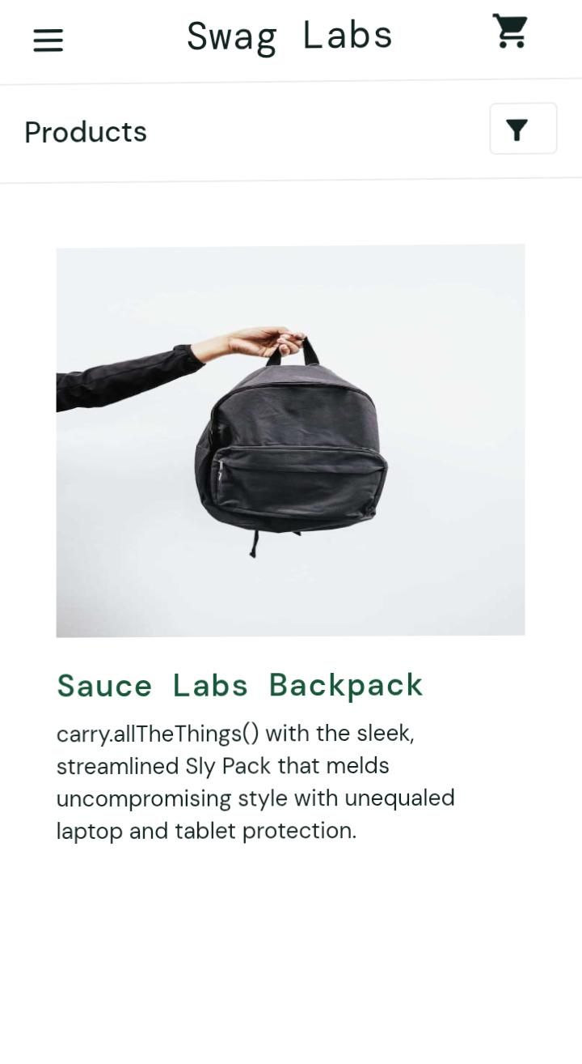
screenshot of a successful login.
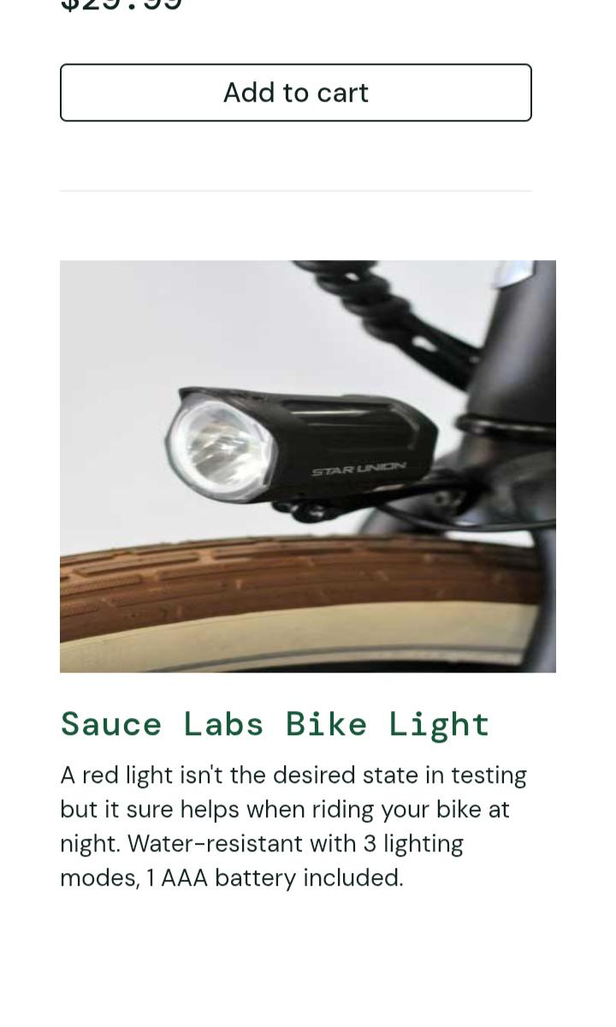
Screenshot of inventory page
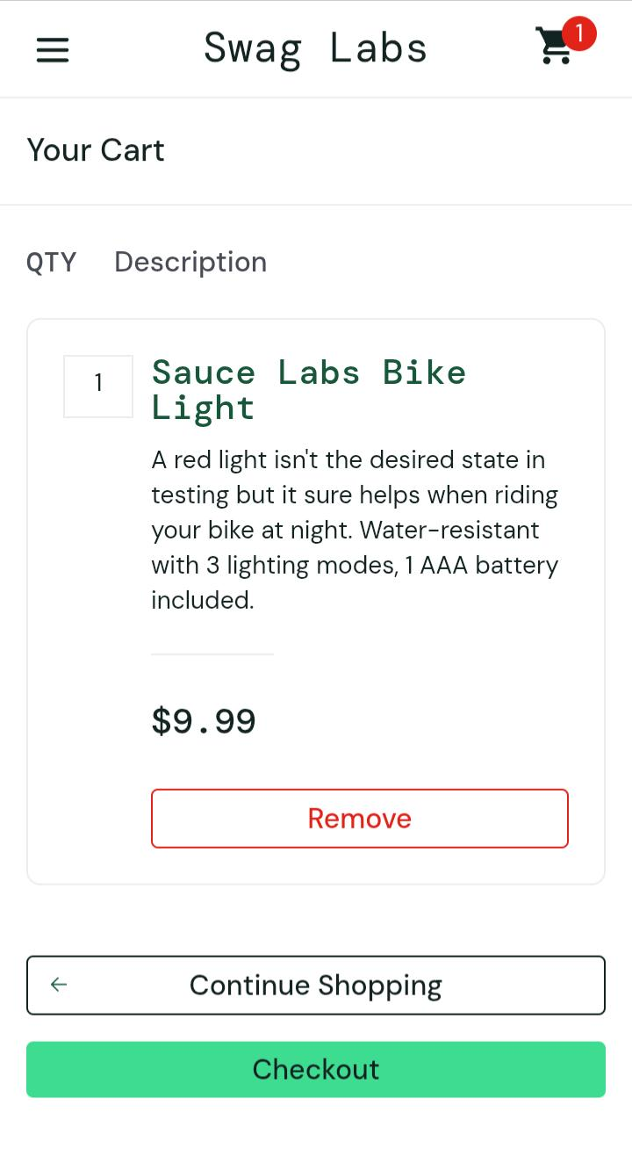
Screenshot showing item added to cart.
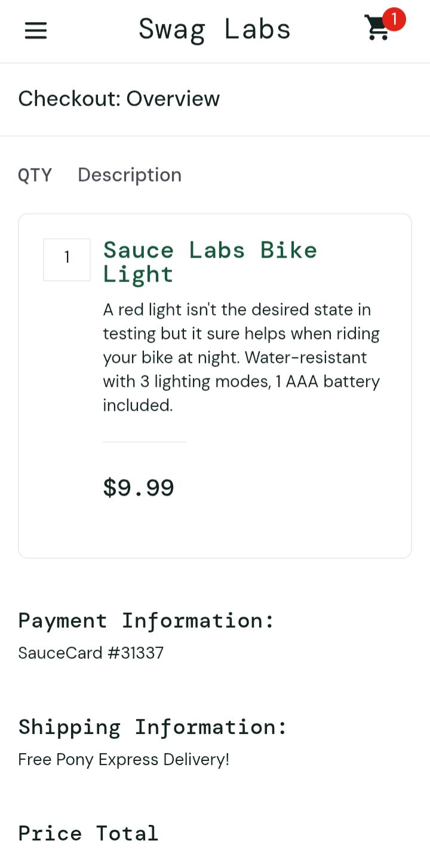
Screenshot of checkout page.
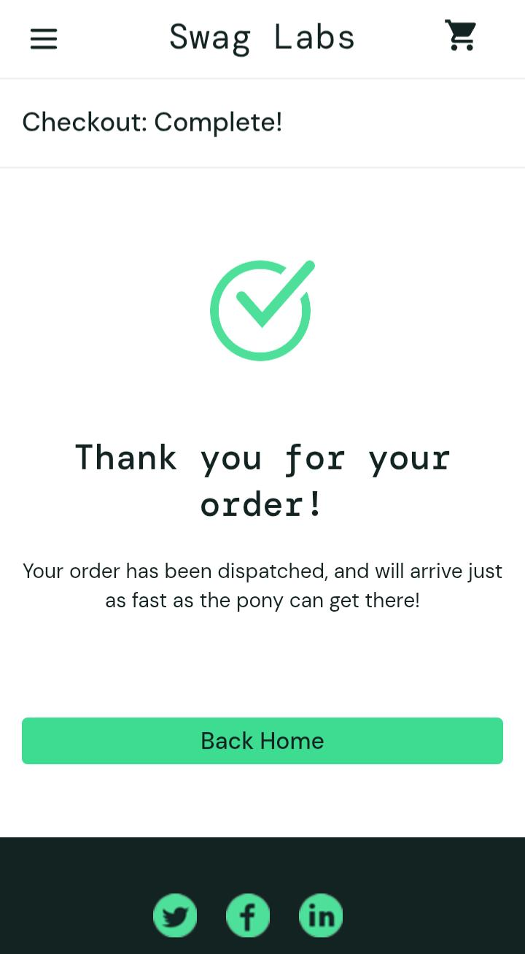
Screenshot of successful order confirmation.

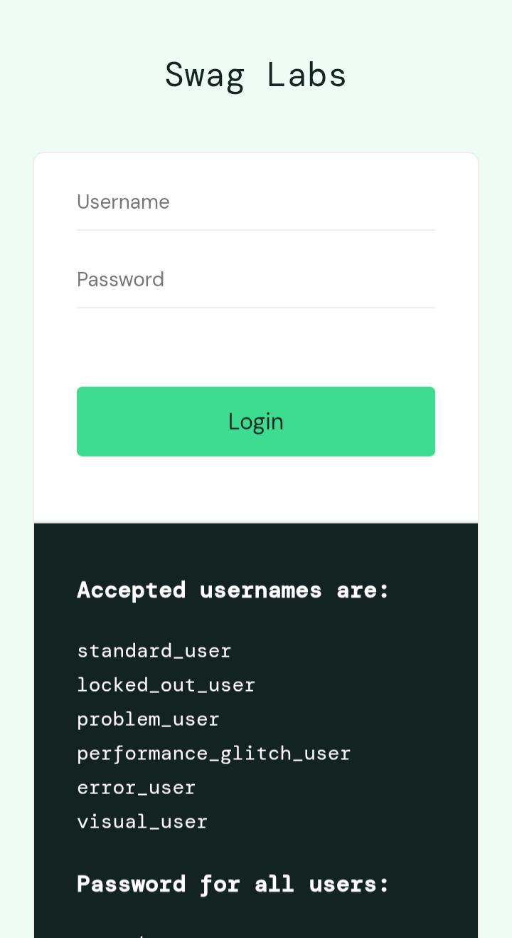
Screenshot of successful logout.
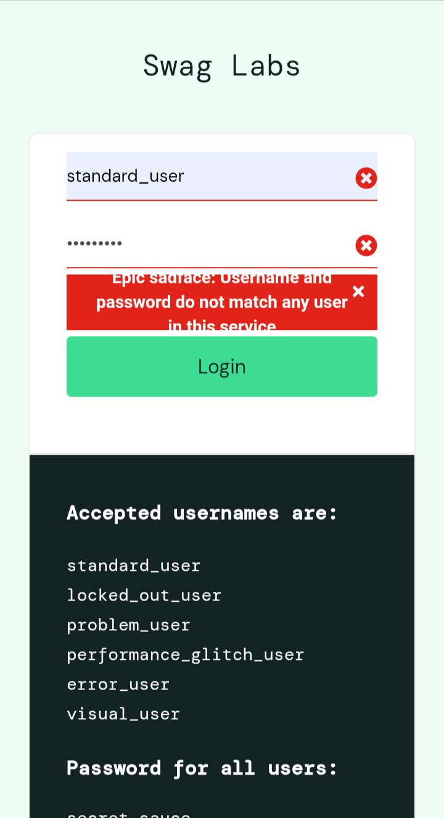
screenshot of valid username and wrong password
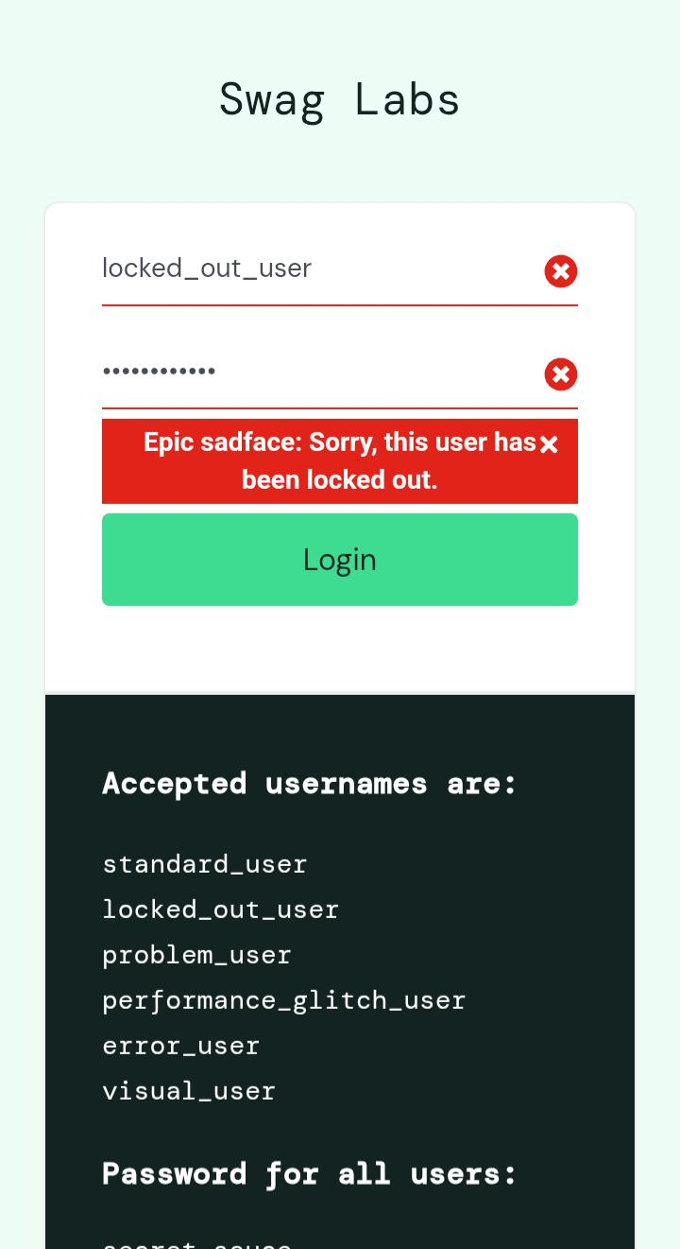
screenshot of a locked_out_user credentials
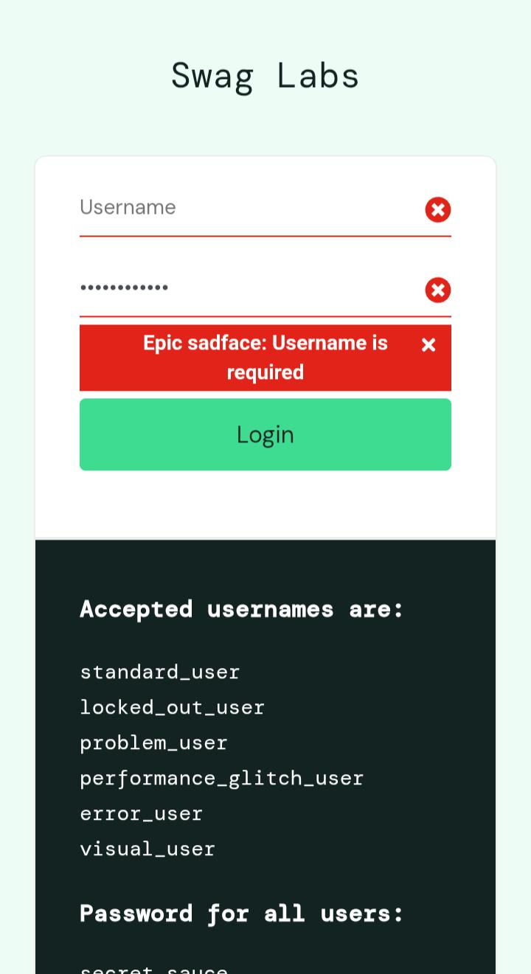
Screenshot of a username blank and click Login
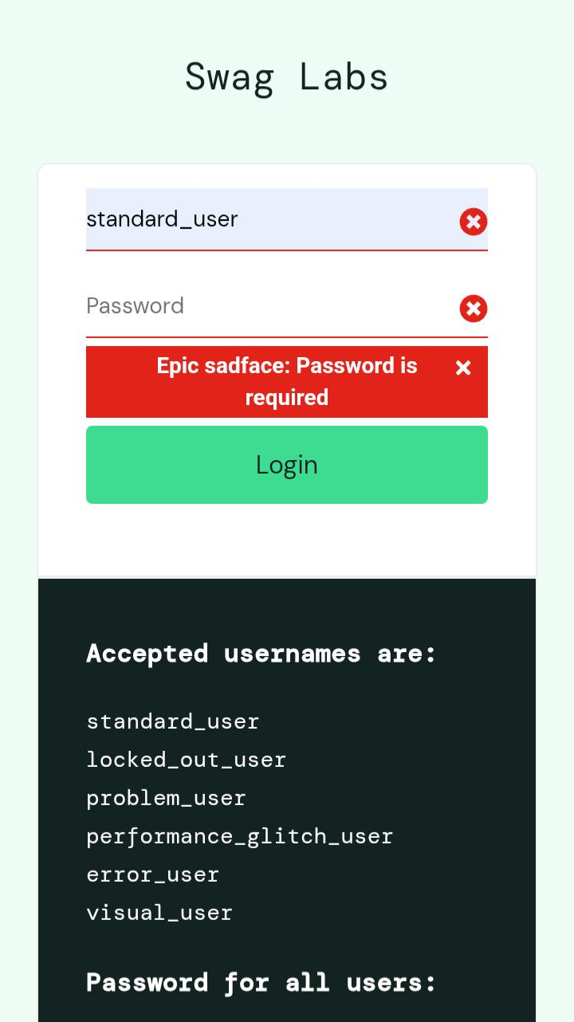
Screenshot of an empty password
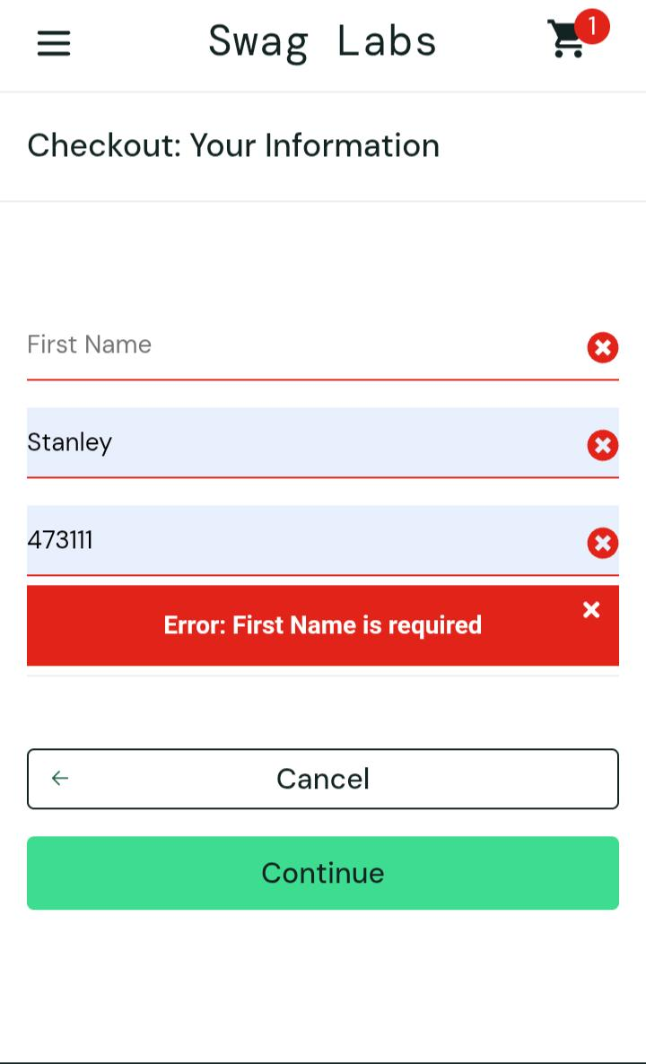
Checkout without first name (Negative)
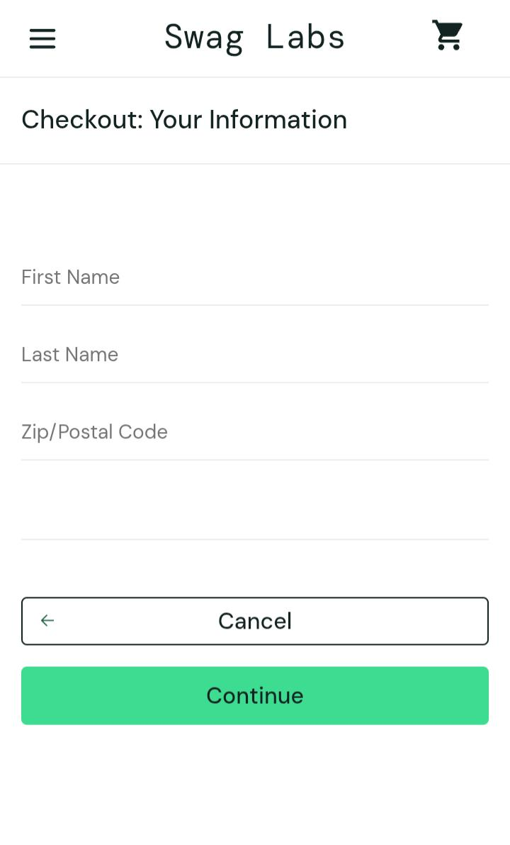
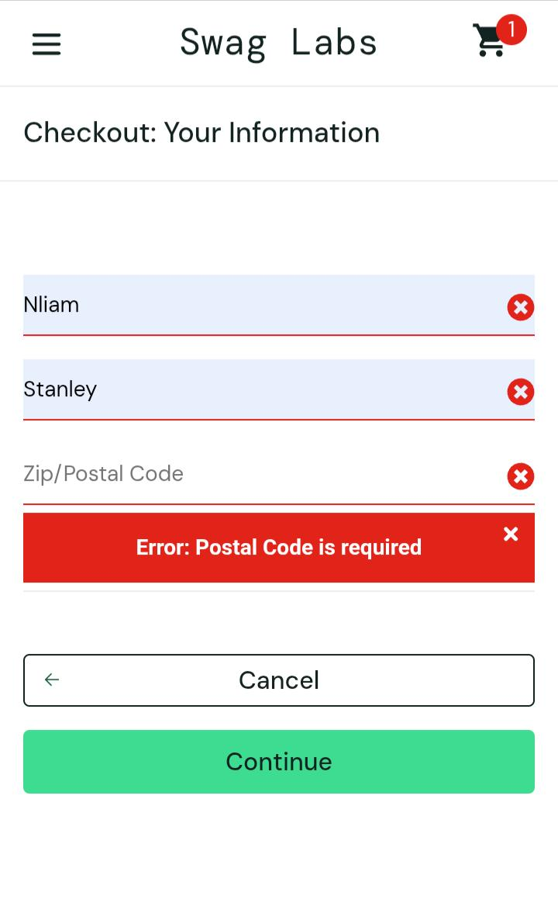
10. Conclusion

The SauceDemo application was tested using functional and negative testing techniques. Fifteen test cases covering login, inventory management, cart operations, checkout validation, order completion, and logout functionality were executed successfully. One low-severity defect was identified during checkout navigation testing. Overall, the application demonstrated stable performance within the tested scope. Continued regression testing and automation of critical workflows are recommended to maintain software quality.

